Beit Hamikdash

Part 1
- Open Woodworking inches & feet.
  - Import Image: Base Bottom, use as Image. 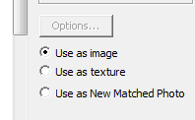
  - With the T – measure 4”. Would you like to resize – yes.
  - Open Layers – place on its own layer: base 1 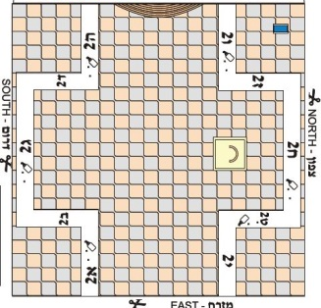
- Add a layer: base 1F. Draw R – around image 4,4. B – make Translucent.
- Raise the tiles area .25” Make a group
- Outside of square: R –1, 1. F – 1/8” inside
- Raise inside wall 1/8, outer walls .75”
- Add a 5/16” cube in one corner, ctrl +M at the other end, / 5 and continue around the top.
- Triple click, right click, & make a component.
- Place on all 4 corners.
- Base: P-.75” for North, East, South. 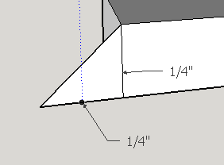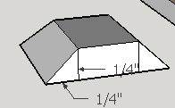
Add a triangular edge. Add 3 Lines, select them, follow me
- Balcony: make outside: 2,1/8 P - .75, make a component. Add to 3 sides.
- Guard’s tower: .5,.5 – P -1” two corners. Add cubes on top
- Outer walls – from the existing walls R – tracing inner wall, P- 1/8, up 7/8”. Add cubes

Part 2
- Start at Eastern wall. Find the midpoint T – 2”
- Guides: .25” each side, .5 up
- Outside of the square, create a doorway: .5 width, .5 high and adorn like photo or as you choose. 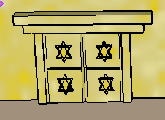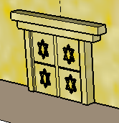 Make sure it has depth.
- Make the entire structure a component – Part 1

Part 3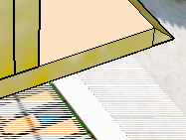
- Add base 2 on a new layer. Line it up to base 1. R – 5 1/2,3, ^ . 1/8. Group and another R- next to it with the same dimensions. Ctrl + M group it
- Building: 2.75, .5 ^ 2. Decorate with doors, columns
  - Behind building: 2, 2 ^ .75 & 1, 1.5 ^ top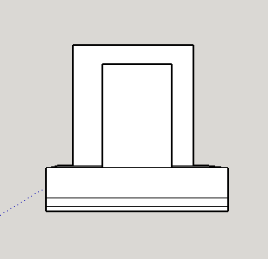
Main Building 2.75, .5^ 2.5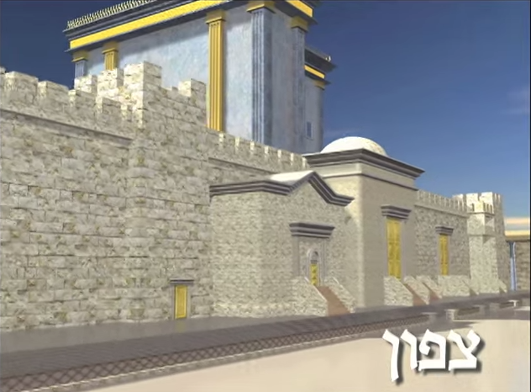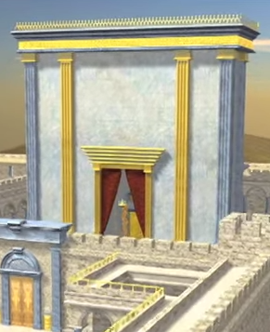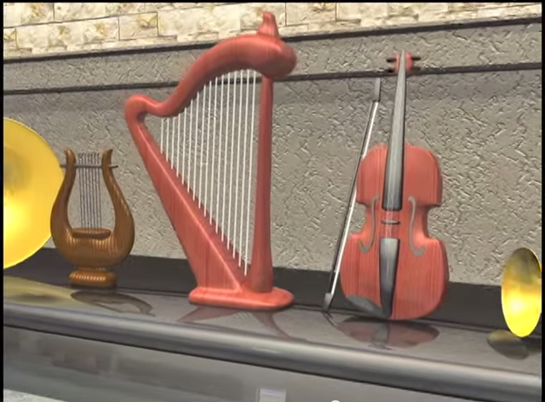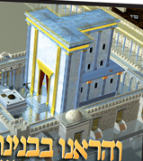These vessels and objects have been constructed precisely from the original materials such as gold and copper.
The objects on display include musical instruments for the Levites to play, including a harp and a lyre. There is a gold incense altar, incense chalice and incense shovel for the ketoret, or incense offering.
- 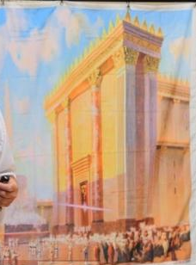https://www.google.com/search?q=beit+hamikdash+museum&espv=2&biw=1242&bih=585&tbm=isch&tbo=u&source=univ&sa=X&ved=0CDAQsARqFQoTCMOKqcfu-MYCFYI4PgodKwUArg#imgrc=zMKDqtiwGr2MZM%3A

http://virtualjerusalem.com/holidays.php?Itemid=4331 Tisha B'Av: The Price of Disunity

Insights into the destruction of the Second Temple

